**C188 – Software Engineering**

|  |
| --- |
| American Video Game Company |
| CRM Proposal |
| Customer Relationship Management – Requirements and Solution |

|  |
| --- |
| Joe Seymour - 004521088  9-7-2022  Version 1.0 |

Contents

A. Introduction 3

A.1. Purpose Statement 3

A.2. Overview of the Problem 3

A.3. Goals and Objectives 3

A.4. Prerequisites 3

A.5. Scope 3

A.6. Environment 3

B. Requirements 4

B.1. Business Requirements 4

B.2. User Requirements 4

B.3. Functional Requirements 4

B.4. NonFunctional Requirements 4

C. Software Development Methodology 5

C.1. Advantages of the waterfall method 5

C.2. Disadvantages of the waterfall method 5

C.3. Advantages of {a different method} 5

C.4. Disadvantages of {a different method} 5

C.5. Best suited 5

D. Design 6

D.1. Storyboard or Flowchart (Change title to fit needs) 6

D.2. UML Diagram (Change title to fit needs) 7

D.3. GUI (Change title to fit needs) 8

E. Testing 9

E.1. Testing Type (change name to fit your needs) 9

E.1.1. Test Name 1 9

E.1.2. Test Name 2 9

E.1.3. Test Name 3 10

F. Sources 12

# Introduction

The American Video Game Company has grown sales significantly over the last two years. With this growth, their current Customer Relationship Management (CRM) system has become a constraint and they are looking for a new CRM to enable better management of automated and disconnected processes. As such, the American Video Game Company has sent a document with its vision for what this new CRM will look like once it has been implemented.

# A.1. PUrpose Statement

This document will provide goals for the new CRM, walk through the requirements of the business, provide details on the implementation, and discuss the methods used while delivering the solution. It will also specify test cases and the software lifecycle details, as well as give the American Video Game Company a thorough understanding of the scope of the project.

# A.2. Overview of THE PROBLEM

With their growth, the American Video Game Company will need a significant upgrade of its current CRM system. There are a significant number of steps that are either manual and/or disconnected that are ripe for automation to deliver additional productivity to the company. The new system will need to enable better efficiency for client contacts, sales tracking, activity management, and reporting.

# A.3. Goals and Objectives

In addition to the enhancements and enablement mentioned above, the American Video Game Company is looking for the following goals and objectives to be achieved:

Consolidate all contact and business information

Manage all activities and track sales

Report the company’s activities and interactions with contacts

Control access to the features via roles and permission for internal and remote users

This will include access for 3rd parties

Allow integration with other systems, containing the sharing of data

Has the ability to be enhanced and scaled for the future

Provide robust security with good audit abilities for administrative users

A precise support and maintenance plan, inclusive of a roadmap for future updates

The ability to extend, modify, and integrate in the future without reliance on a single company or team

Clear documentation around the solution will be tantamount to success

The licensing model and ownership rights for custom development

Work on the internal hosting infrastructure or have justification for the alternative

Ensure an intuitive user-friendly system to maximize user efficacy

All data must be housed in the United States

Anything processed, analyzed, or shared should be included unless otherwise approved

# A.4. Prerequisites

The follow prerequisites will be required prior are critical for the project to be successful:

|  |  |  |  |
| --- | --- | --- | --- |
| Number | Prerequisite | Description | Completion Date |
| 1 | None | Document user needs and system requirements that clearly relate to the goals of the project. | 10/1/2022 |
| 2 | None | Document current system and the integration points with external systems. | 10/1/2022 |
| 3 | None | Initial budget defined delivered by American Video Game Company | 10/1/2022 |
| 4 | 3 | Acceptance of the user needs and system requirements | 11/1/2022 |
| 3 | 3,4 | Agree on scope based on requirements and budget | 11/15/2022 |

# A.5. Scope

The scope of the project will cover the major capabilities of the system. These capabilities include Contact Management, Ticketing, Data Types/Modeling, Reporting, Activity Management, Order Management, and Contacting.

The project will not cover all capabilities. The capabilities that will not be included are Opportunity Management, Quoting, and Forecasting. These can be covered at another time with an additional scope of work.

# A.6. Environment

Describe the IT and hardware environments that the solution will be deployed in.

# Requirements

Provide a brief introduction on requirements. You may select the correct subsections that match the needs of your solution and the key requirements that you identified from the profile document.

*Note: All requirements must be in your own words and interpret the requirements found in the “CRM Requirements” attachment. Please do not copy and paste word for word from the requirements in the “CRM Requirements” attachment.*

# Business Requirements

Provide a brief introduction to the business requirements for the proposed system.

# User Requirements

Provide a brief introduction to the user requirements for the proposed system.

# Functional Requirements

Provide a brief introduction to the functional requirements for the proposed system.

# NonFunctional Requirements

Provide a brief introduction to the nonfunctional requirements for the proposed system.

# SOFTWARE DEVELOPMENT METHODOLOGY

The company has selected the waterfall software development methodology for this project. Examine the waterfall methodology and compare it to other software development methodologies (e.g., Agile). Include a brief introduction to the development process as well.

*Note: All subsections are required. Refer to the requirements section and rubric section of the assessment for additional information.*

# Advantages of the waterfall method

Describe the advantages of the waterfall methodology and how they will benefit this project.

# disAdvantages of the waterfall method

Describe the disadvantages of the waterfall methodology and how they may hinder this project.

# Advantages of {A DIFFERENT METHOD}

Describe the advantages of a different methodology and how they will benefit this project.

# disAdvantages of {A DIFFERENT method}

Describe the disadvantages of a different methodology and how they may hinder this project.

# best SUITED

Describe why the waterfall methodology is the best software development methodology for this project.

**OR**

Provide the details of a different development process and outline why you would have selected it and how it would have been better suited for this project.

# Design

Provide a brief overview of the proposed design.

*Note: These subsections may be copied, rearranged, and modified to fit the needs of the solution. At least two visual representations of your design need to be present.*

# Storyboard or Flowchart (Change title to fit needs)

Provide a storyboard or flowchart of the application.

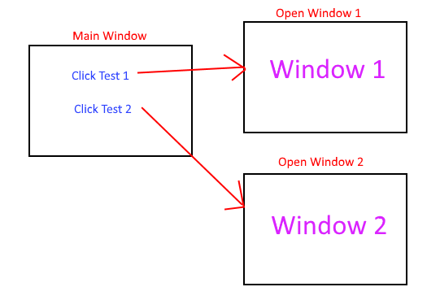

Figure 1: Sample Storyboard

# UML Diagram (Change title to fit needs)

Provide a set of UML diagrams that cover the proposed solution. This can include but is not limited to class diagrams, database diagrams, and use case diagrams. Also, ensure that all diagrams are clearly discussed and noted.

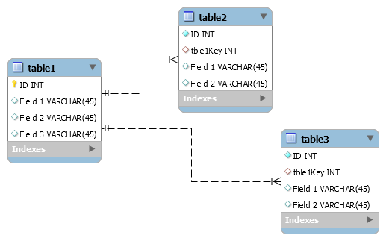

Figure 2: Sample Database

# GUI (Change title to fit needs)

Provide a mock-up of the proposed GUI forms that will be used in the proposed solution. Also, clearly indicate where the GUI components point inside the application.

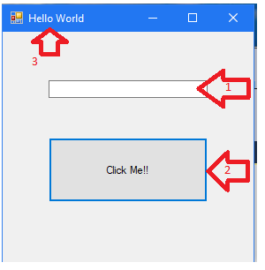

Figure 3: Sample GUI Mock-up

|  |  |  |  |
| --- | --- | --- | --- |
| GUI Control Mapping | | | |
| ID | Control | Property | Data Source |
| 1 | Textbox | On application open text = “” or null | NA |
| 1 | Textbox | On click of button text = “Hello World” | Internal Variable |
| 2 | Button | On click change text of textbox 1 to “Hello World” | Internal Variable |
| 3 | Form | Text= “Hello World” |  |

# Testing

Provide a brief introduction to the proposed testing solution. The tests need to be from 3 completely different functionality aspects. Testing the same aspect with slightly different criteria is not acceptable.

**Note: *Add and remove subsections as needed to cover all the testing needs.*

# Testing Type (change name to fit your needs)

Provide a brief introduction paragraph.

# Test Name 1

|  |
| --- |
| Requirement to be tested |
| Preconditions: Conditions that must be present before test case can successfully run |
| Steps: The steps the tester must execute to test the feature. |
| Expected results: Expected results and any side effects such as updating a database, writing to a file, etc. |
| Pass/Fail: Mark whether the test case passed or failed. The results can be compiled and used to determine if the application is ready for delivery/release. |

# Test Name 2

|  |
| --- |
| Requirement to be tested |
| Preconditions: Conditions that must be present before test case can successfully run |
| Steps: The steps the tester must execute to test the feature. |
| Expected results: Expected results and any side effects such as updating a database, writing to a file, etc. |
| Pass/Fail: Mark whether the test case passed or failed. The results can be compiled and used to determine if the application is ready for delivery/release. |

# Test Name 3

|  |
| --- |
| Requirement to be tested |
| Preconditions: Conditions that must be present before test case can successfully run |
| Steps: The steps the tester must execute to test the feature. |
| Expected results: Expected results and any side effects such as updating a database, writing to a file, etc. |
| Pass/Fail: Mark whether the test case passed or failed. The results can be compiled and used to determine if the application is ready for delivery/release. |

# Sources

Place the sources that you used here.

*Note: See the sources section in the requirements and rubric. If you did not use any outside sources, you may delete this section.*